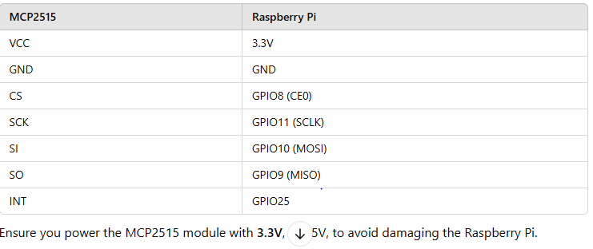

sudo nano /boot/firmware/config.txt

dtparam=spi=on

dtoverlay=mcp2515-can0,oscillator=8000000,interrupt=25

dtoverlay=spi-bcm2835

sudo reboot

sudo apt update

sudo apt install can-utils

sudo apt install can-utils python3-pip python3-venv

sudo ip link set can0 up type can bitrate 500000

ifconfig can0

sudo ip link set can0 down

sudo apt install python3-venv –y

python3 -m venv can_env

source can_env/bin/activate

pip install python-can

python -c "import can; print(can.__version__)"

//Sending CAN Messages

import can

def send_can_message():

bus = can.interface.Bus(channel='can0', bustype='socketcan')

msg = can.Message(arbitration_id=0x123, data=[0x11, 0x22, 0x33, 0x44, 0x55, 0x66, 0x77, 0x88], is_extended_id=False)

try:

bus.send(msg)

print(f"Message sent: {msg}")

except can.CanError:

print("Failed to send message")

if __name__ == "__main__":

send_can_message()

python send_can.py

// Receiving CAN Messages

import can

def receive_can_message():

bus = can.interface.Bus(channel='can0', bustype='socketcan')

print("Listening for CAN messages... Press Ctrl+C to exit.")

try:

while True:

msg = bus.recv()

if msg:

print(f"Received message: ID={hex(msg.arbitration_id)} Data={msg.data}")

except KeyboardInterrupt:

print("\nStopped receiving messages.")

if __name__ == "__main__":

receive_can_message()

sudo nano /etc/network/interfaces

auto can0

iface can0 inet manual

pre-up /sbin/ip link set can0 type can bitrate 500000

up /sbin/ifconfig can0 up

down /sbin/ifconfig can0 down

sudo reboot

ip link show can0

dmesg | grep spi

dmesg | grep can

OPEN PROJECT

cd can_project

source venv/bin/activate

sudo ip link set can0 up type can bitrate 500000

python : file_name.py

python receive_can.py

RQQQQQQQQQQQQQQQQQ : if it won't send do this cmd then bitrate

sudo ip link set can0 down